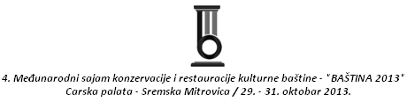

4. MEĐUNARODNA KONFERENCIJA KULTURNOG TURIZMA
Učešće kulturnog turizma u turističkoj ponudi Srbije

THE 4th INTERNATIONAL CONVENTION OF CULTURAL TOURISM
Participation of Cultural Tourism in Tourist Attractions of Serbia

PRIJAVA ZA KONFERENCIJU / REGISTRATION FOR THE CONFERENCE

Naziv organizacija/
Organization Name
Država/ State
Grad/ City
Autori i naslov rada/
Authors and title of work
Tel./fax. - Phone/Fax
Kontakt e-mail/Contact Email
Tema/Topic

Jezik/Language
Rok za prijavljivanje/  The deadline for applications | 01.10.2013.
Prijavu možete izvršiti na/  The application can be made to | E-mail: region1@open.telekom.rs

Sažetak/Abstract
Datum /Date: Potpis/Signature:

