18. strokovno srečanje konservatorjev-restavratorjev v Narodni galeriji
Strokovno srečanje in razstava plakatov
V Narodni galeriji bo 15. maja 2018 v organizaciji Skupnosti muzejev Slovenije, Društva restavratorjev Slovenije in Narodne galerije s pričetkom ob 10.00 potekalo 18. strokovno srečanje konservatorjev-restavratorjev, kjer bodo sodelujoči iz Slovenije in širše regije predstavljali svoje delo s plakati, kratkimi filmi in predavanji. Predavanja in predstavitve bodo namenjene strokovni javnosti.
Stroka pa se želi s spremljevalno razstavo, ki bo predstavila aktualne projekte, približati tudi širši javnosti. Razstava plakatov bo na ogled do torka 22. maja 2018, vsak dan razen ponedeljka, od 10. do 18. ure, v četrtek do 20. ure. Vstop je prost. Vabljeni k ogledu!
Na razstavi plakatov bodo predstavljeni številni projekti. Omeniti velja posege na delih Ptičar in Prestar Fortunata Berganta ter delo hrvaških kolegov na sliki ekstremnih dimenzijami (447 × 795 cm) Srečanje papeža Leona I. Velikega z Atilo. Med arheološko problematiko izstopajo posegi na kovinskem gradivu, ki so ga v preteklosti renovirali zasebni zbiralci z metodami, ki so za muzejsko gradivo povsem neprimerne. Med stenskimi slikami je posebej zanimiv prispevek o problematiki prezentacije preteklih posegov na srednjeveških stenskih poslikavah v cerkvi na Vrzdencu. Izjemno zahtevna so bili tudi dela na štukaturah češkega kiparja Vaclava Macha na fasadi Obrtne šole na Aškerčevi v Ljubljani.
Srečanje je del 11. Konservatorsko-restavratorske transverzale, serije dogodkov med 25. aprilom in 11. junijem 2018.

18th Conservator-Restorers’ Professional Meeting
Professional Meeting and Poster Exhibition
On 15 May 2018, the National Gallery of Slovenia is hosting the 18th Conservator-Restorers’ Professional Meeting, where participants from Slovenia and the wider region will present their work through posters, short videos and lectures. The event is organised together with the Slovenian Museums Association and the Slovenian Restorers Association. The lectures and presentations start at 10am and aim at expert public.
Wider public will be able to learn more about past and ongoing projects at the exhibition of posters that will run 15–22 May 2018 and will be open every day except Monday, from 10am to 6pm, on Thursday until 8pm. Admission to this exhibition is free. You are kindly invited!
The exhibition will feature many projects, among them the work on The Fowler and Man with a Pretzel by Fortunat Bergant and the work of Croatian colleagues on a large-scale (447 x 795 cm) painting The Meeting of Pope Leon the Great with Attila. Among archaeological challenges, the interventions on iron material stand out, since the artefacts were originally renovated by private collectors using methods completely at odds with museum standards. Wall painting interventions include an interesting report on the church in Vrzdenec and the challenges of presenting past interventions in medieval wall paintings. Also incredibly difficult was the intervention on the stuccowork by Czech sculptor Vaclav Mach on the façade of the arts and crafts school on Aškerc Street in Ljubljana.

Nosilci projekta: Narodna galerija, Skupnost muzejev Slovenije in Društvo restavratorjev Slovenije
15.maj – 22. maj 2018
Narodna galerija
Prešernova 24
1000 Ljubljana

Podpisi k slikam:

Slika1: 17. strokovno srečanje konservatorjev-restavratorjev 2017 (foto: J. Dermastja)
Slika 2: Razstava plakatov 2017 (foto: J. Dermastja)
Slika 3: Strokovna predavanja in predstavitve 2017 (foto: J. Dermastja)
Slika 4: Optične preiskave na slikah Fortunata Berganta Ptičar in Prestar (foto: A. Hirci)
Slika 5: Detajl slike Prestarja med retuširanjem Narodna galerija (foto: Simona Škorja)
Slika 6: Srečanje papeža Leona I. Velikega z Atilo pred restavriranjem in med posegi, Strossmajerjeva galerija,Hrvaška (foto: Ljubo Gamulin)

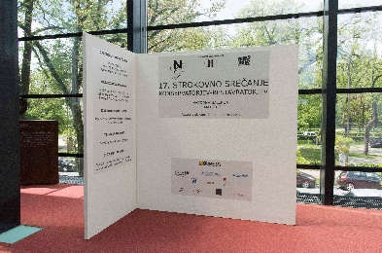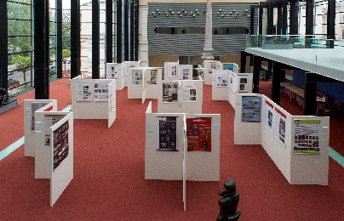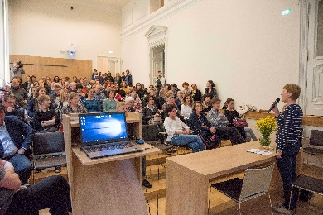
1 2 3

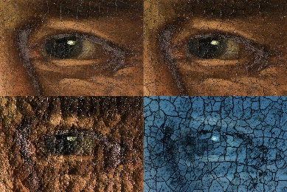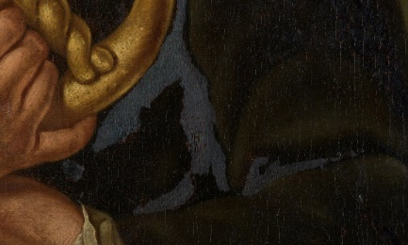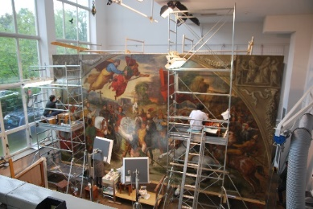
4 5 6

